Check for Storage space (RAM) in the PC and verify if the Kali Linux is compatible.

Search for Kali Linux download in the browser, select the proper file that needs to download based on PC and click on the download button.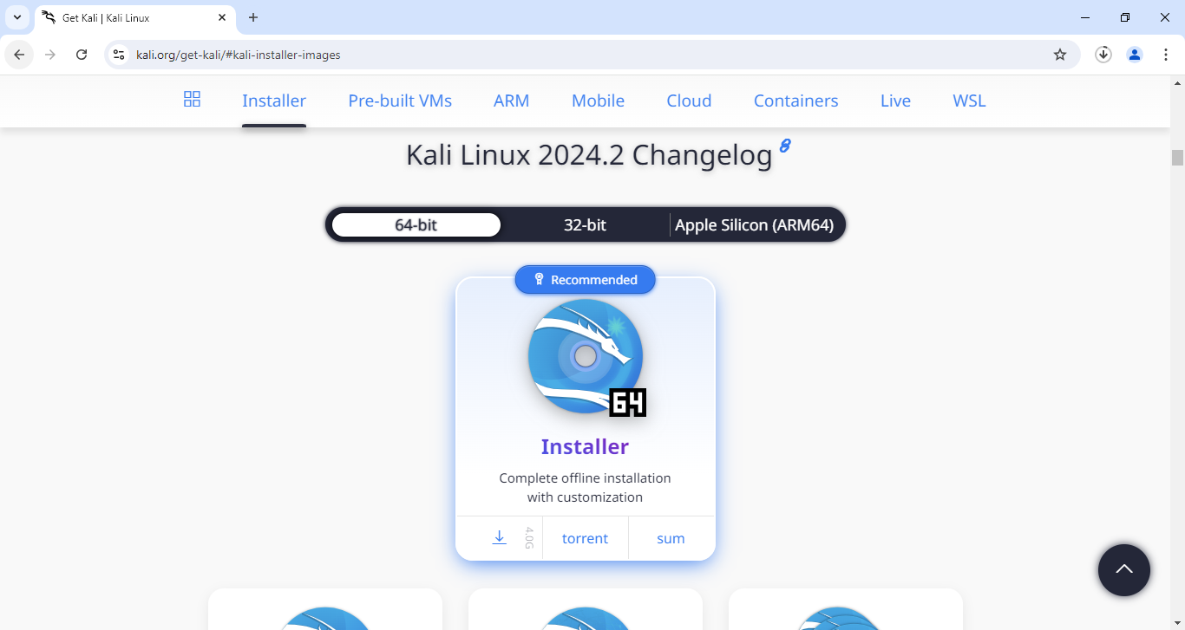

Once downloaded, click on the downloaded iso file and follow all the instruction mentioned in the installation process.

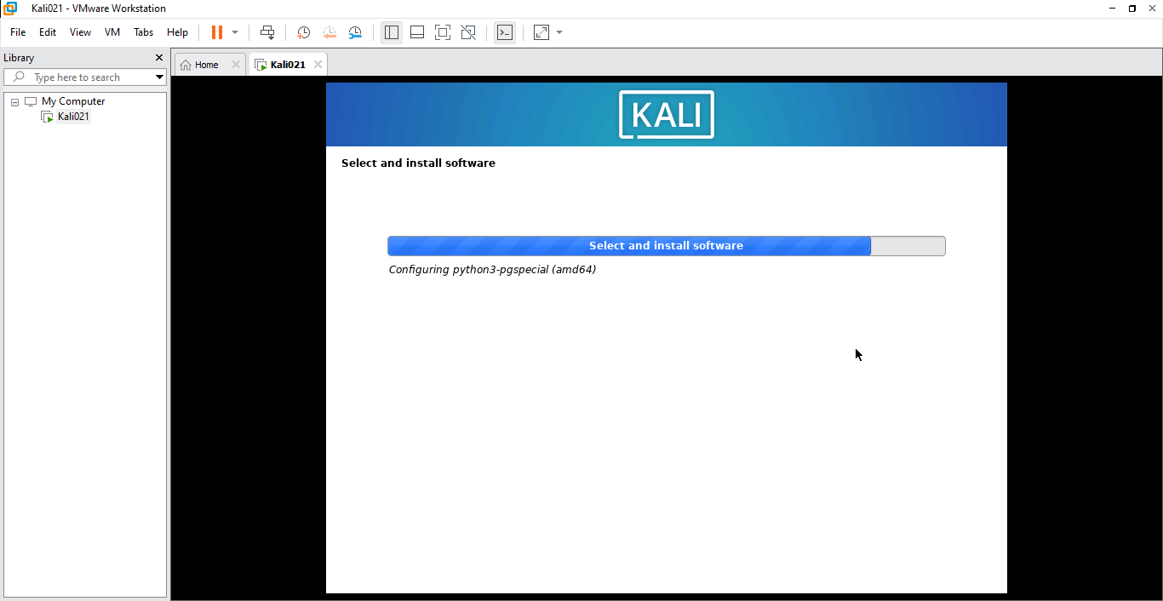

Once all the instructions are followed and installed, restart the Virtual machine and login to the kali linux using username and the password that is been set recently while installing.

